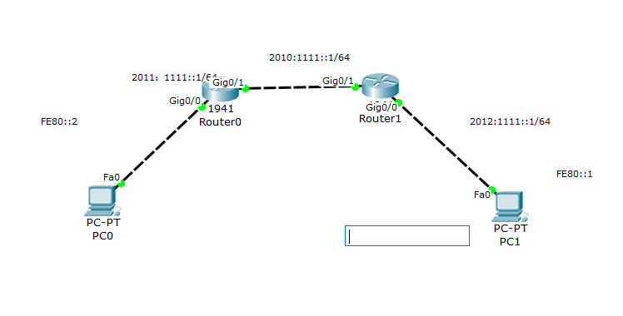

Router0：

En

Conf t

Ipv6 unicast-routing (开启ipv6功能，允许转发)

Int g0/0

Ipv6 address 2011:1111::1/64 (配置IPv6的IP地址)

Ipv6 address FE80::2 link-local (配置本地链路地址)

Int g0/1

Ipv6 address 2010:1111::1/64

Ipv6 address FE80::2 link-local

Exit

Ipv6 router rip cisco(cisco 只是一个进程号)

Int g0/0

Ipv6 rip cisco enable (相当于宣告网段的功能)

Int g0/1

Ipv6 rip cisco enable

Router 1:

En

Conf t

Ipv6 unicast-routing

Int g0/1

Ipv6 address 2010:1111::2/64

Ipv6 address FE80::1 link-local

Int g0/0

Ipv6 address 2012:1111::1/64

Ipv6 address FE80::1 link-local

Ipv6 router rip cisco(cisco 只是一个进程号)

Int g0/0

Ipv6 rip cisco enable

Int g0/1

Ipv6 rip cisco enable